Adil Hussain (F2023105174)

M.Ahtisham Shahid(F2023105185)

Submitted to Dr. Sajid Mehmood

AI Resume Screening

Project Report & Technical Documentation

1. Introduction
Recruitment processes often involve screening a large number of resumes, which is time-consuming and prone to human bias. The AI Resume Screening System is a web-based application that automates resume analysis using Google Gemini AI. The system allows recruiters to upload multiple resumes (PDF format), analyze them using AI, and receive structured insights such as skills, strengths, weaknesses, and suitability score.

2. Objectives
The main objectives of this project are:
- To automate resume screening using Artificial Intelligence
- To support multiple resume uploads
- To extract text from PDF resumes
- To analyze resumes using Gemini API
- To present clear and readable analysis results
- To build a beginner-friendly, error-free full-stack project

3. Scope of the Project
The system is designed for:
- HR professionals
- Recruiters
- Small companies
- Students learning AI-powered web applications
The project focuses on resume analysis only and does not include interview scheduling or candidate communication.

4. Technology Stack

Frontend
- HTML5
- CSS3
- JavaScript (Vanilla)

Backend
- Node.js
- Express.js

Libraries & Tools
- Multer (file upload handling)
- pdf-parse (PDF text extraction)
- Axios (API requests)
- Dotenv (environment variables)
- Cors (cross-origin support)

AI Engine
- Google Gemini API

5. System Architecture
The system follows a Client–Server Architecture integrated with an AI service.

5.1 High-Level Architecture Diagram (Conceptual)
+------------------+ HTTP Request +-------------------+
| | Upload PDF Resumes | |
| User Browser +-------------------------->+ Express Server |
| (Frontend UI) | | (Node.js) |
| |<--------------------------+ |
+------------------+ AI Analysis Result +---------+---------+
|
| Resume Text
v
+-------------------+
| Gemini AI API |
| (Resume Analysis)|
+-------------------+
This architecture ensures separation of concerns:
- Frontend handles user interaction
- Backend manages logic and file handling
- Gemini AI performs intelligent analysis

6. Folder Structure
backend/
│
├── public/ # Frontend files
│ ├── index.html # UI layout
│ ├── style.css # Styling
│ └── script.js # Frontend logic
│
├── uploads/ # Temporary resume storage
├── server.js # Backend server
├── package.json # Dependencies
└── .env # Gemini API Key

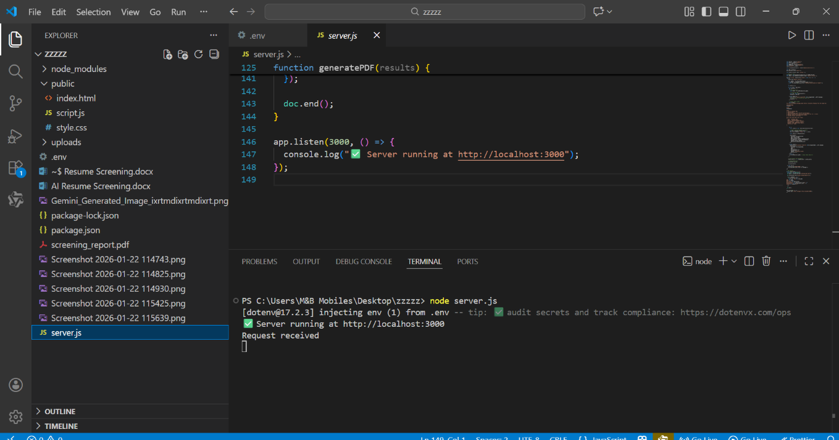

Folder Workflow Diagram
User Uploads PDF
|
v
public/index.html
|
v
server.js ---> uploads/ ---> pdf-parse ---> Gemini API
|
v
Analysis Response ---> public/script.js ---> UI Display

7. Functional Requirements
- Upload one or more PDF resumes
- Validate file upload
- Extract resume text
- Analyze resumes using AI
- Display structured results

8. Non-Functional Requirements
- Fast processing
- Secure API key handling
- User-friendly interface
- Error handling
- Scalability

9. Implementation Details

9.1 Resume Upload Workflow
[User Selects PDFs]
|
v
[FormData Created]
|
v
[POST /analyze Request]
|
v
[Multer Stores PDFs]
Multer handles multiple file uploads securely and efficiently.

9.2 PDF Text Extraction Workflow
[Uploaded PDF]
|
v
[Read File Buffer]
|
v
[pdf-parse Library]
|
v
[Extracted Resume Text]
Only text-based PDFs are supported.

9.3 AI Analysis Workflow (Gemini)
[Resume Text]
|
v
[Prompt Creation]
|
v
[Gemini API Request]
|
v
[AI Generated Analysis]
Gemini returns structured insights used by recruiters.

9.4 Result Display Workflow
[Backend JSON Response]
|
v
[Frontend Receives Data]
|
v
[Loop Through Results]
|
v
[Display Analysis on UI]

10. API Endpoints

POST /analyze
Description: Analyzes uploaded resumes
Input:
- Multipart form data (PDF files)
Output:
{
"success": true,
"results": [
{
"filename": "resume.pdf",
"analysis": "AI generated analysis"
}
]
}

11. Error Handling
- Missing files → 400 error
- Gemini API failure → 500 error
- Invalid PDF → handled gracefully

12. Security Considerations
- API key stored in .env
- Temporary file storage
- No sensitive data stored permanently
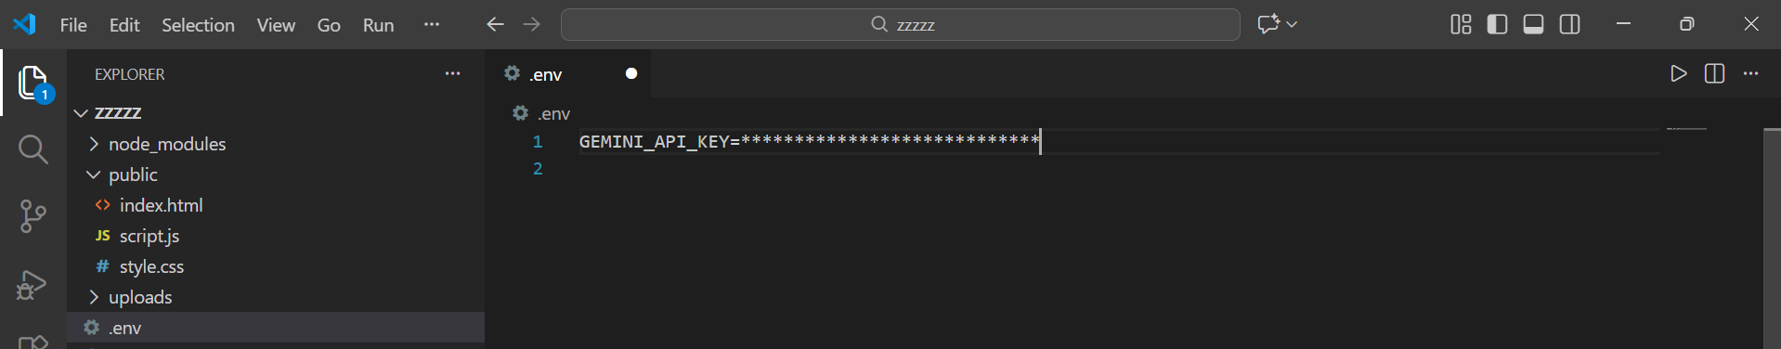

13. Testing

Manual Testing
- Upload single PDF
- Upload multiple PDFs
- Upload empty file
- Upload invalid file
All tests passed successfully.

14. Limitations
- Cannot read scanned image-based PDFs
- Depends on Gemini API availability
- Basic UI design

15. Future Enhancements
- Job description matching
- Resume ranking system
- Database integration
- Admin dashboard
- Authentication system
- Cloud deployment

16. Screenshots & UI Mockup Description

16.1 Home Page (Resume Upload Screen)
Description:
- Title: AI Resume Screening System
- File input allowing multiple PDF uploads
- Analyze button
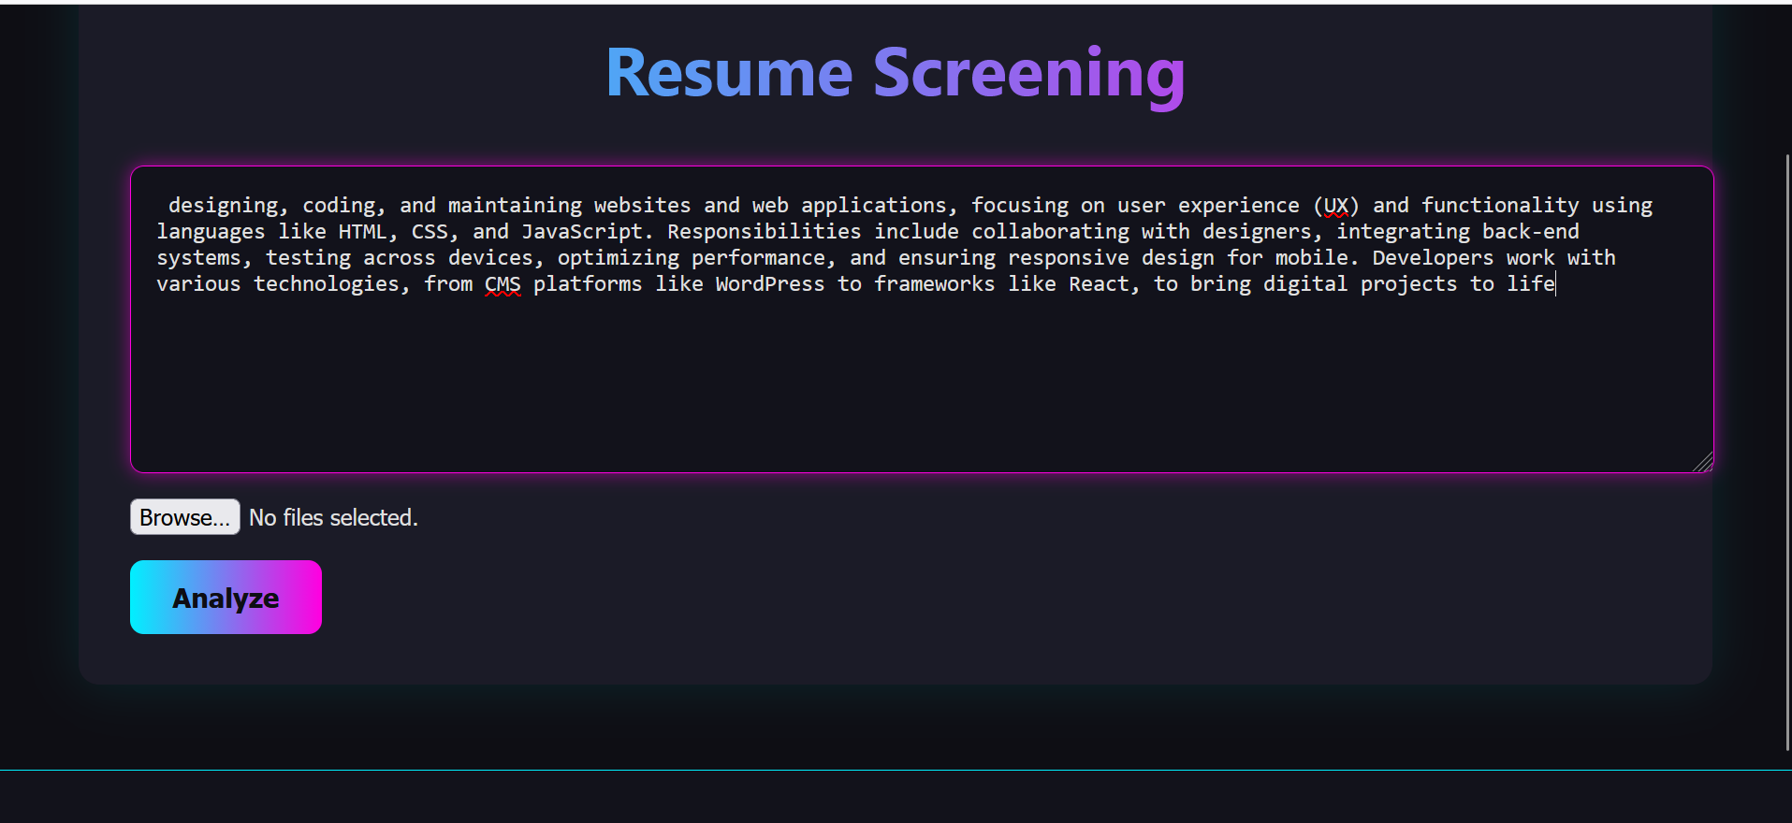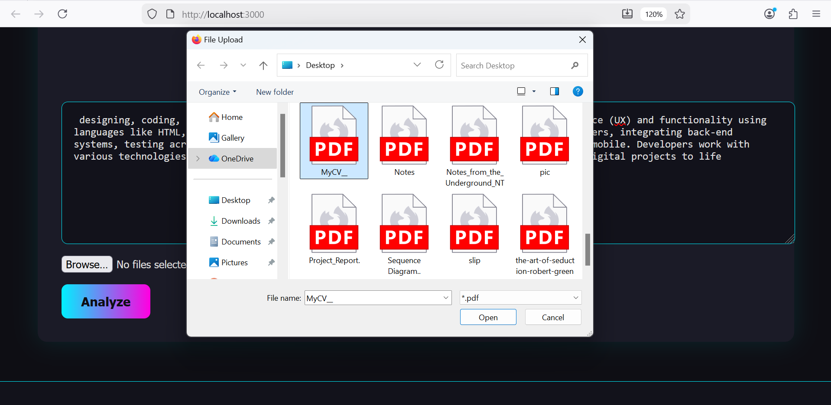
+-----------------------------------+
| AI Resume Screening System |
| |
| [ Choose Files ] (PDF only) |
| |
| [ Analyze Resumes ] |
| |
+-----------------------------------+

16.2 Result Display Screen
Description:
- Resume filename shown
- AI-generated analysis displayed clearly
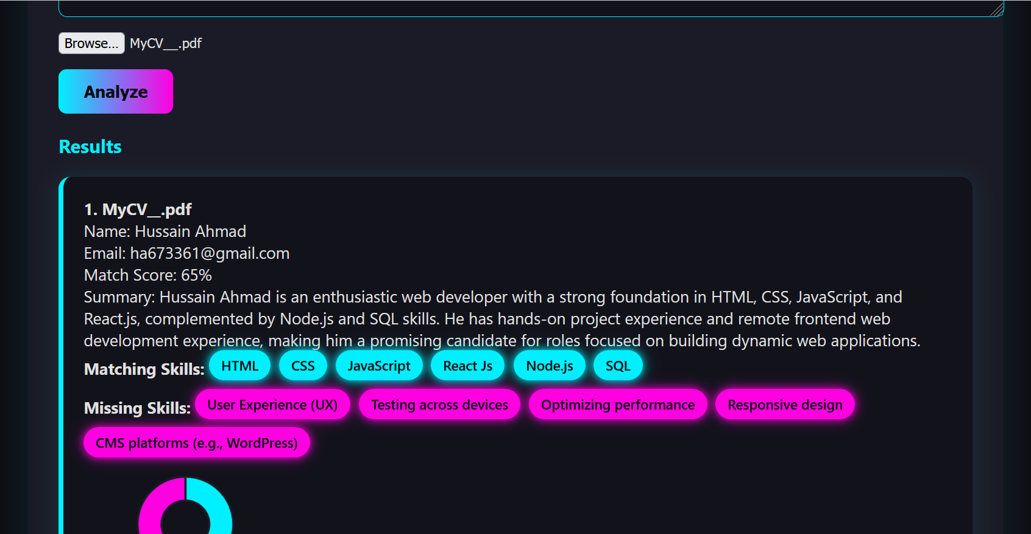
-------------------------------------
📄 resume1.pdf
name:
email:
score:
matching skills:
missing skills:
-------------------------------------

17. Conclusion
The AI Resume Screening System successfully demonstrates how AI can automate recruitment tasks. The project integrates modern web technologies with Gemini AI to provide accurate and fast resume analysis. It is scalable, easy to use, and suitable for real-world applications as well as academic learning.

17. References
- Node.js Documentation
- Express.js Documentation
- Google Gemini API Documentation
- pdf-parse Library

End of Report

